MEAN, MEDIAN
Pearson Edexcel – Monday 8 June 2020 - Paper 3 (Calculator) Higher Tier
1.
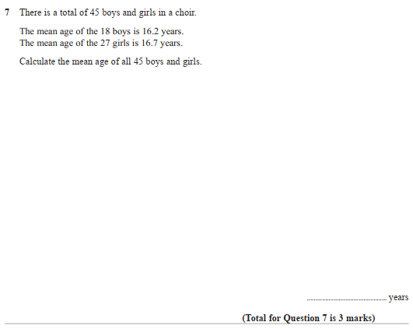

Pearson Edexcel – Monday 8 June 2020 - Paper 3 (Calculator) Higher Tier
2.
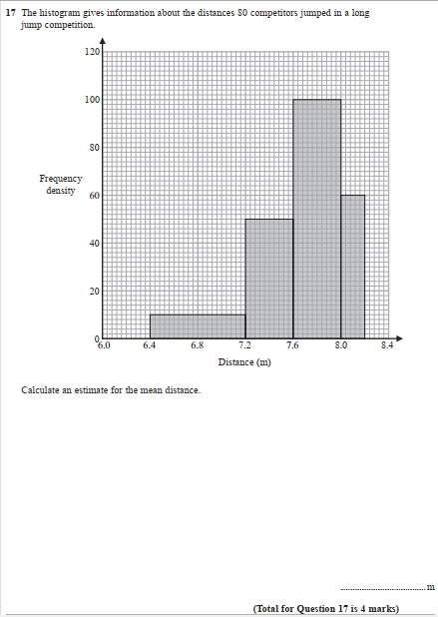

Pearson Edexcel - Tuesday 21 May 2019 - Paper 1 (Non-Calculator) Higher Tier
3.
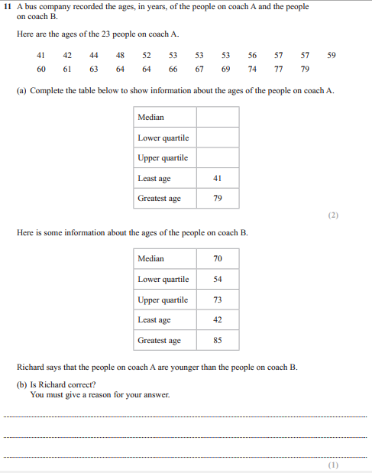
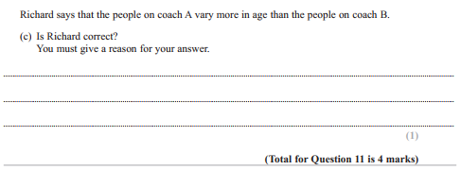

Pearson Edexcel - Monday 6 November 2017 - Paper 2 (Calculator) Higher Tier
4.
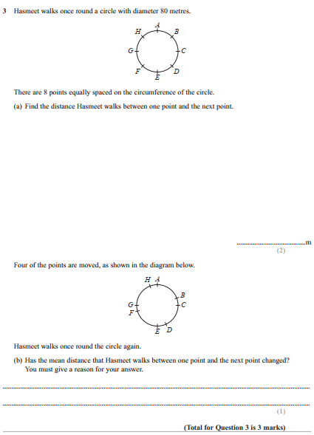

Pearson Edexcel - Wednesday 8 November 2017 - Paper 3 (Calculator) Higher Tier
5.
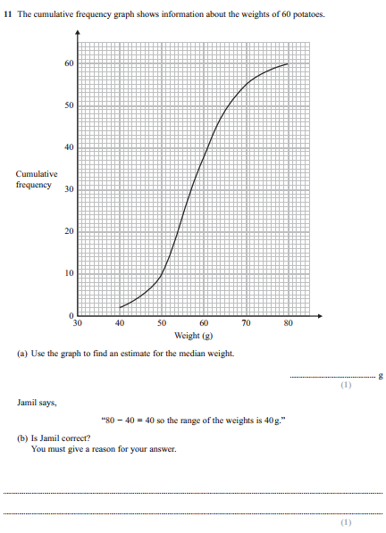
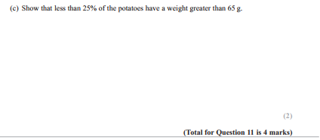
Pearson Edexcel - Thursday 25 May 2017 - Paper 1 (Non-Calculator) Higher Tier
6.
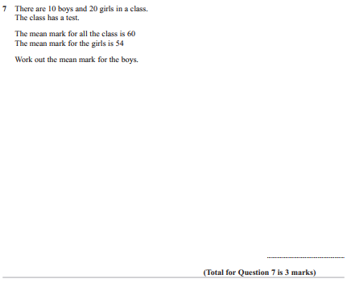

Pearson Edexcel - Tuesday 13 June 2017 - Paper 3 (Calculator) Higher Tier
7.
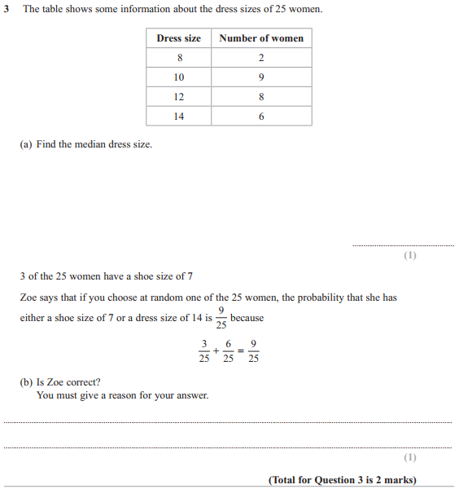

Pearson Edexcel - Specimen Papers Set 2 - Paper 1 (Non-Calculator) Higher Tier
8.
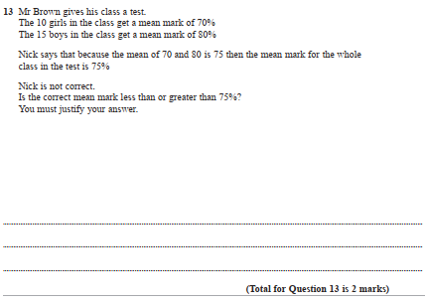
Pearson Edexcel - Specimen Papers Set 1 - Paper 1 (Non-Calculator) Higher Tier
9.
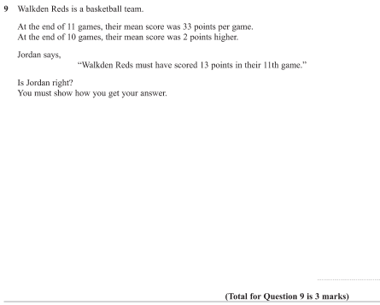
Pearson Edexcel - Wednesday 4 November 2015 - Paper 1 (Non-Calculator) Higher Tier
10.
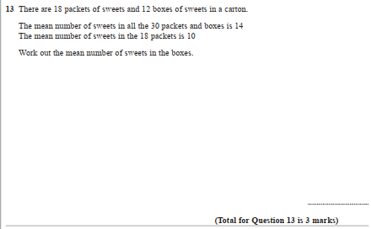

Pearson Edexcel - Friday 13 June 2014 - Paper 2 (Calculator) Higher Tier
11.
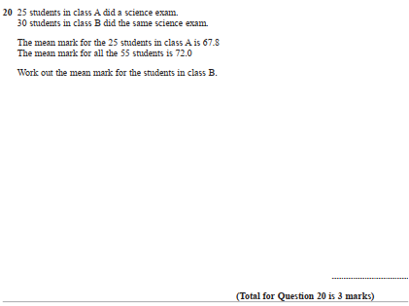

Pearson Edexcel - Wednesday 6 November 2013 - Paper 1 (Non-Calculator) Higher Tier
12.
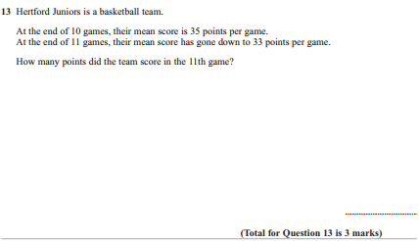

Pearson Edexcel - Tuesday 11 June 2013 - Paper 1 (Non-Calculator) Higher Tier
13.
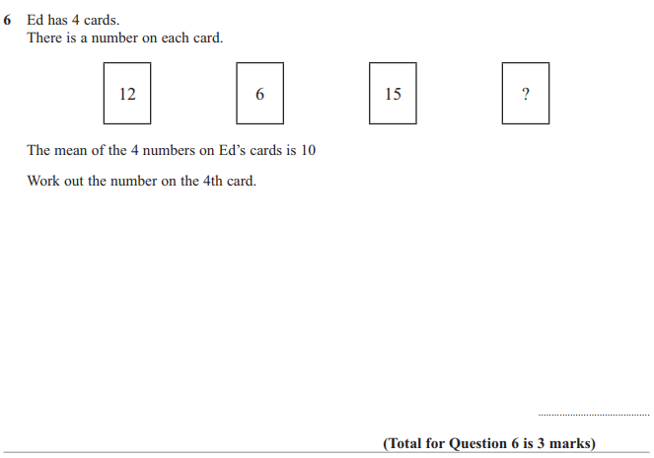

Pearson Edexcel - Wednesday 13 June 2012 - Paper 2 (Calculator) Higher Tier
14.
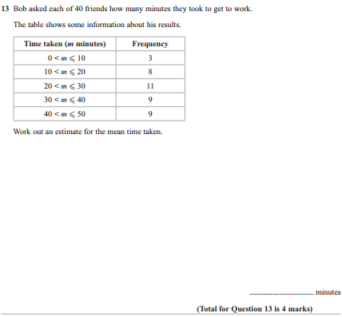
Pearson Edexcel - Monday 5 March 2012 - Paper 4 (Calculator) Higher Tier
15.
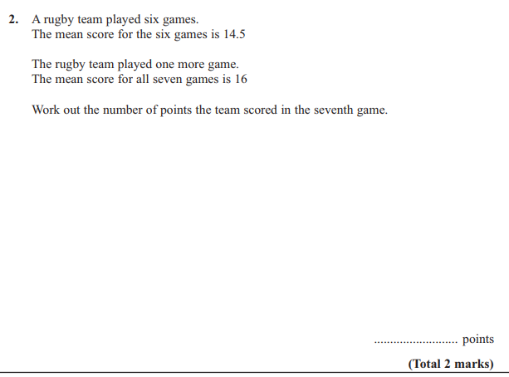
Pearson Edexcel - Friday 10 June 2011 - Paper 4 (Calculator) Higher Tier
16.
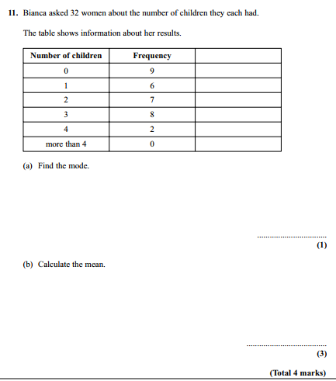

Pearson Edexcel - Tuesday 10 November 2009 - Paper 4 (Calculator) Higher Tier
17.
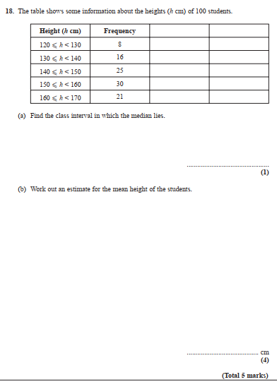
OCR GSCE – Tuesday 3 November 2020 – Paper 4 (Calculator) Higher Tier
18.
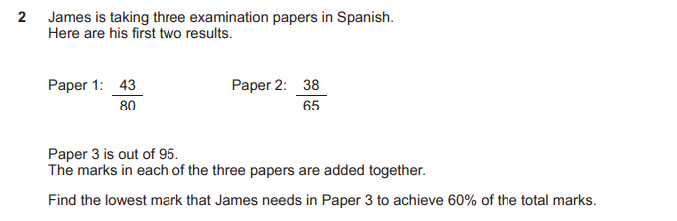
19.

